# BD-7611

To create this test data, the system was moved back to Jun 20th/2022 to test and compare within 30 days prior the effective date (July 15th/2022).

Acceptance Criteria:

Given a new BBR quote in the states of AZ, MI, MN, NJ, and NYFTZ created after this change is live, the quote will use the Surplus rater.

This are pics of the states previously mentioned and Program=RPS-Auto on June 20th/2022

BBR Q#2029530 Admitted

When compared this admitted quote with the surplus rater, this was the result.

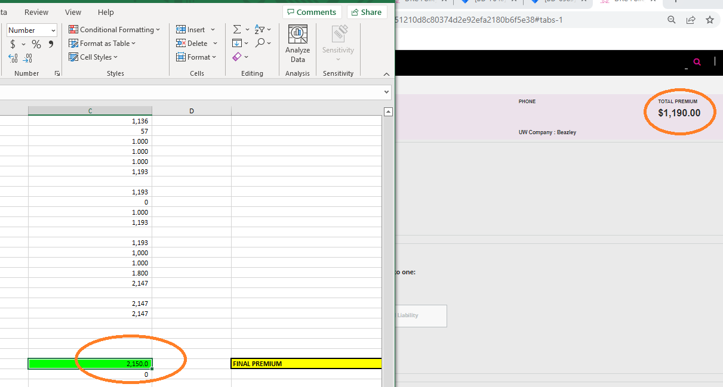

BBR Q#2029531 Admitted

BBR Q#2029532 Admitted

States different from AZ MI MN NJ NYFTZ. (Surplus)

BBR Q#2029533 Surplus

BBR Q#2029534 Surplus

BBR Q#2029535 Surplus

